**Exercise 1: Control Structures**

**Scenario 1**

Code ->

BEGIN

FOR cust_rec IN (SELECT CustomerID, DOB FROM Customers) LOOP

IF MONTHS_BETWEEN(SYSDATE, cust_rec.DOB) / 12 > 60 THEN

UPDATE Loans

SET InterestRate = InterestRate - 1

WHERE CustomerID = cust_rec.CustomerID;

END IF;

END LOOP;

COMMIT;

END;

Output ->

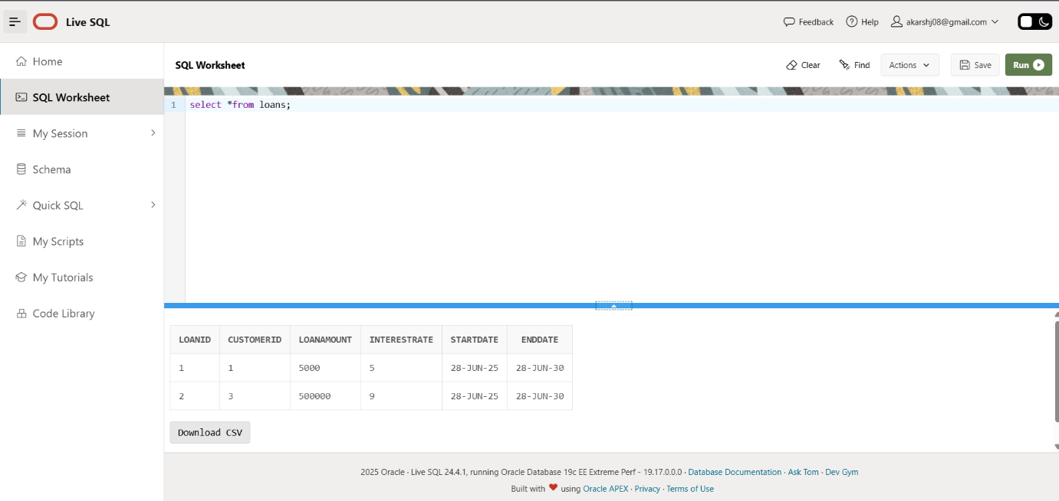

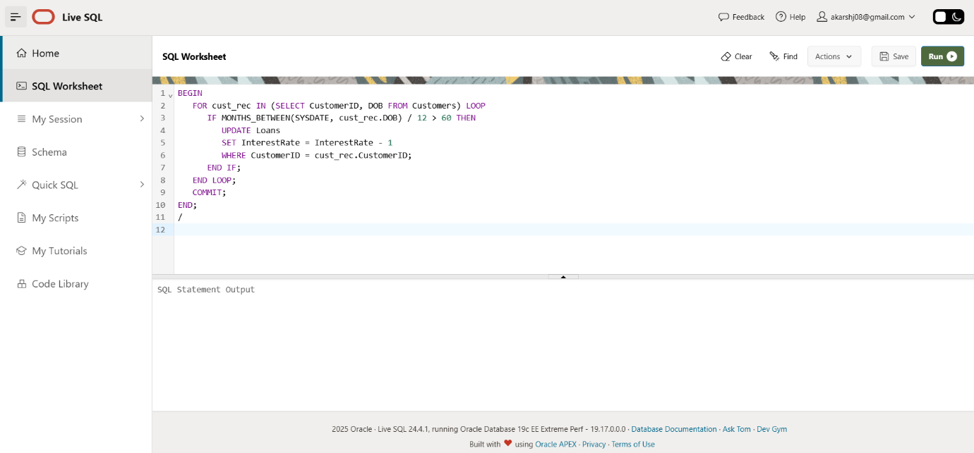

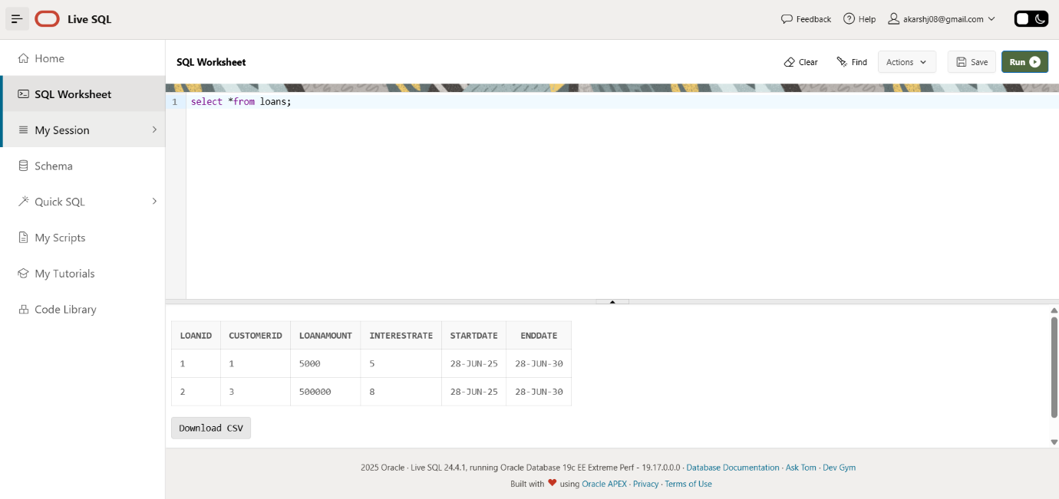

Scenario 2

Code ->

BEGIN

FOR cust_rec IN (SELECT CustomerID, Balance FROM Customers) LOOP

IF cust_rec.Balance > 10000 THEN

UPDATE Customers

SET IsVIP = 'Y'

WHERE CustomerID = cust_rec.CustomerID;

END IF;

END LOOP;

COMMIT;

END;

Output ->

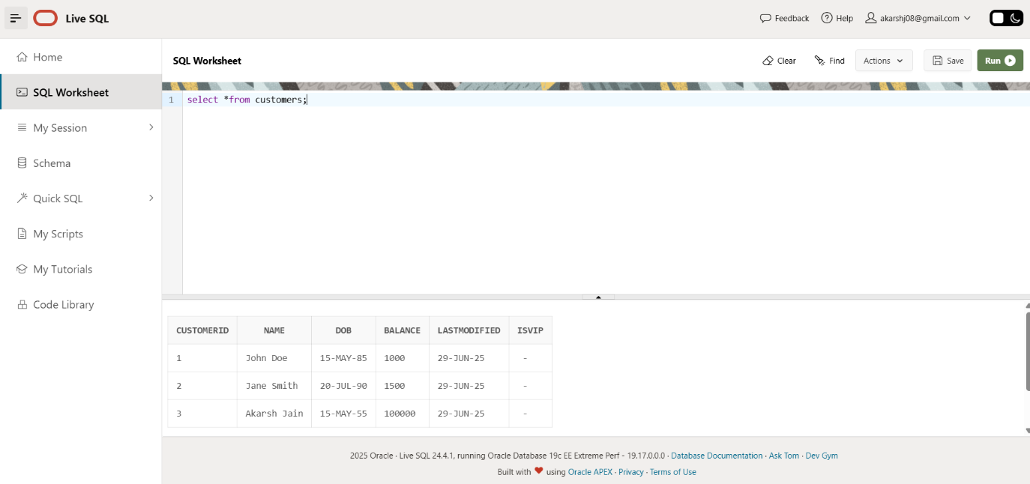

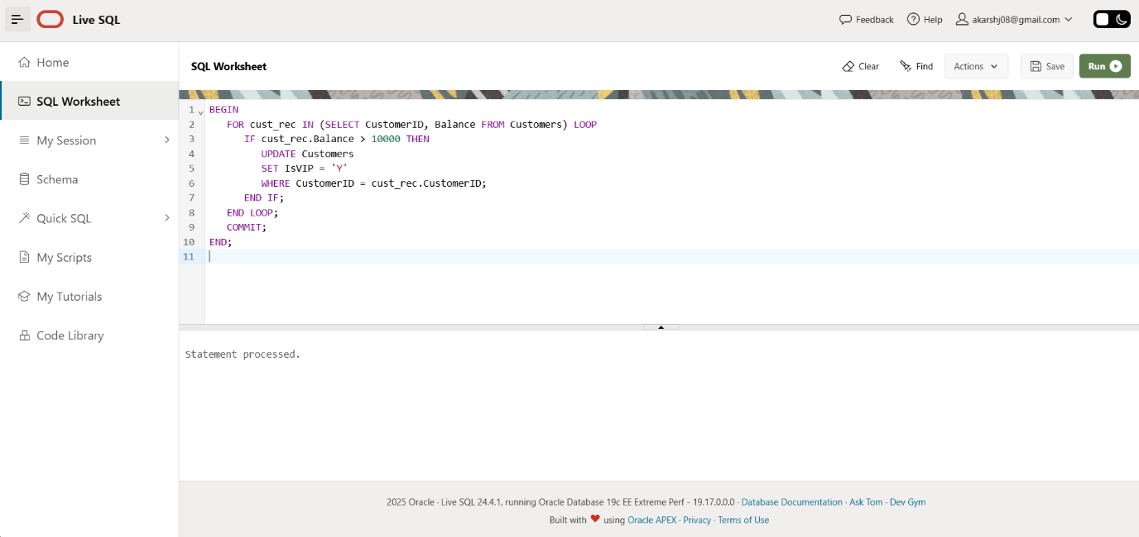

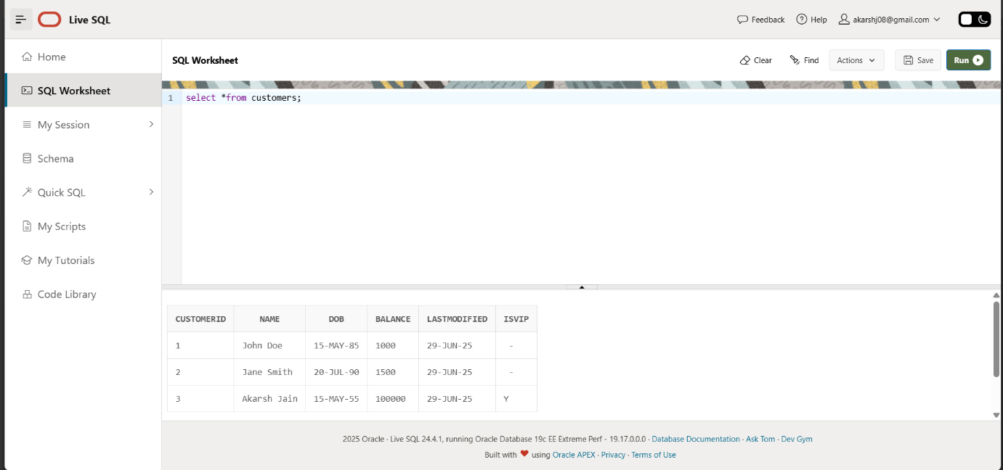

Scenario 3

Code ->

SET SERVEROUTPUT ON;

BEGIN

FOR loan_rec IN (

SELECT L.LoanID, C.Name, L.EndDate

FROM Loans L

JOIN Customers C ON L.CustomerID = C.CustomerID

WHERE L.EndDate <= SYSDATE + 30

) LOOP

DBMS_OUTPUT.PUT_LINE('Reminder: Loan ID ' || loan_rec.LoanID ||

' for ' || loan_rec.Name ||

' is due on ' || TO_CHAR(loan_rec.EndDate, 'YYYY-MM-DD'));

END LOOP;

END;

Output ->

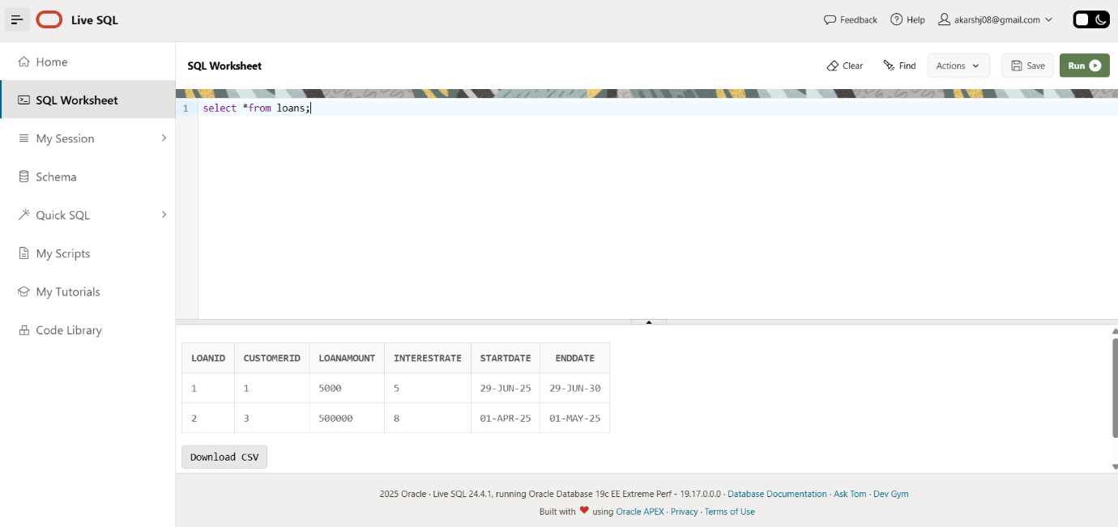

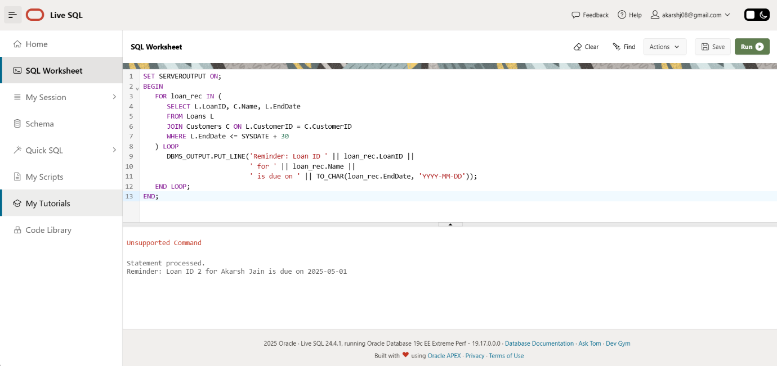

Exercise 3: Stored Procedures

Scenario 1

Code ->

CREATE OR REPLACE PROCEDURE ProcessMonthlyInterest AS

BEGIN

FOR acc_rec IN (

SELECT AccountID, Balance

FROM Accounts

WHERE AccountType = 'Savings'

) LOOP

UPDATE Accounts

SET Balance = Balance + (acc_rec.Balance * 0.01),

LastModified = SYSDATE

WHERE AccountID = acc_rec.AccountID;

END LOOP;

COMMIT;

END;

BEGIN

ProcessMonthlyInterest ();

END;

Output ->

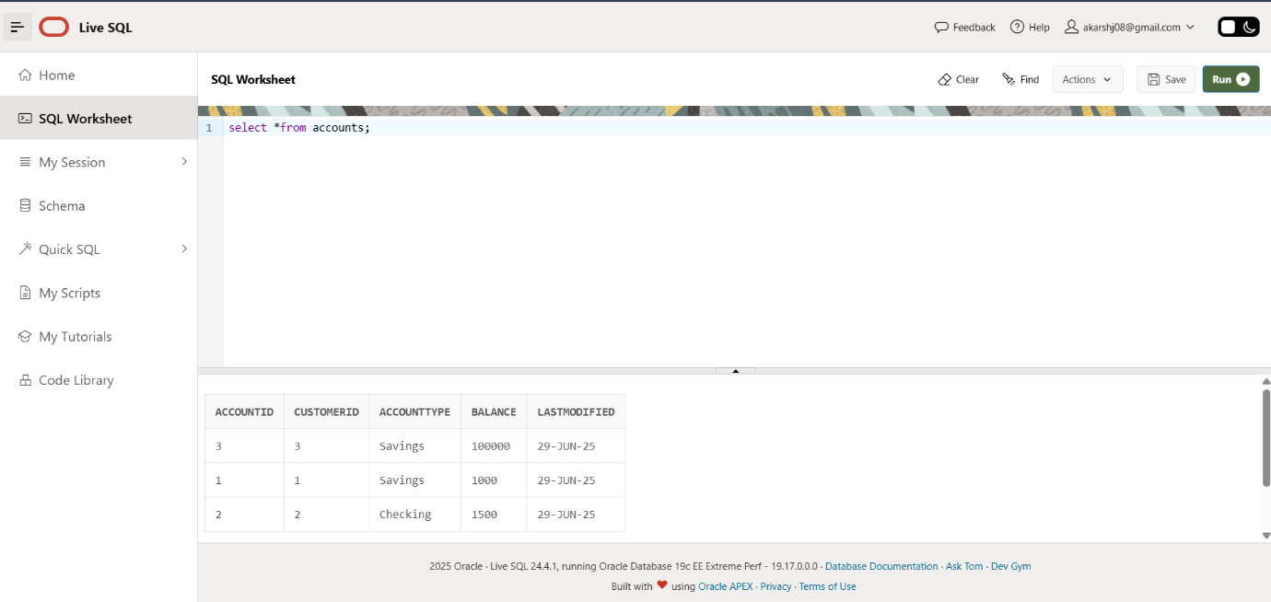

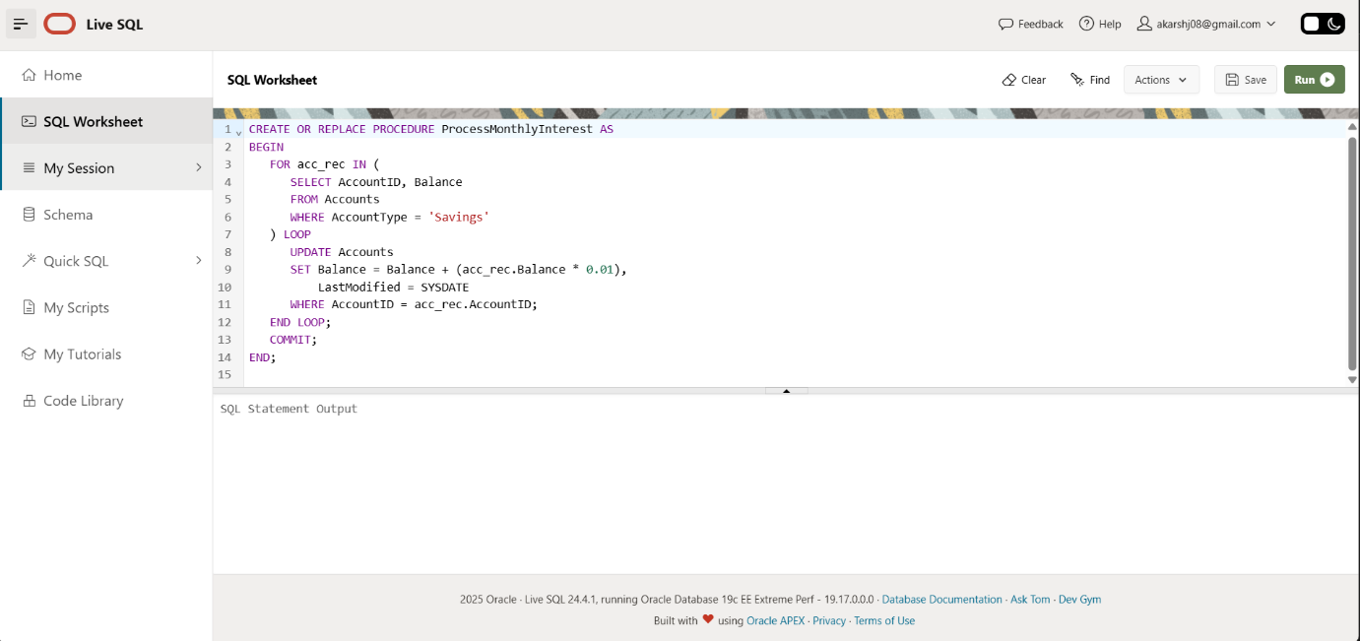

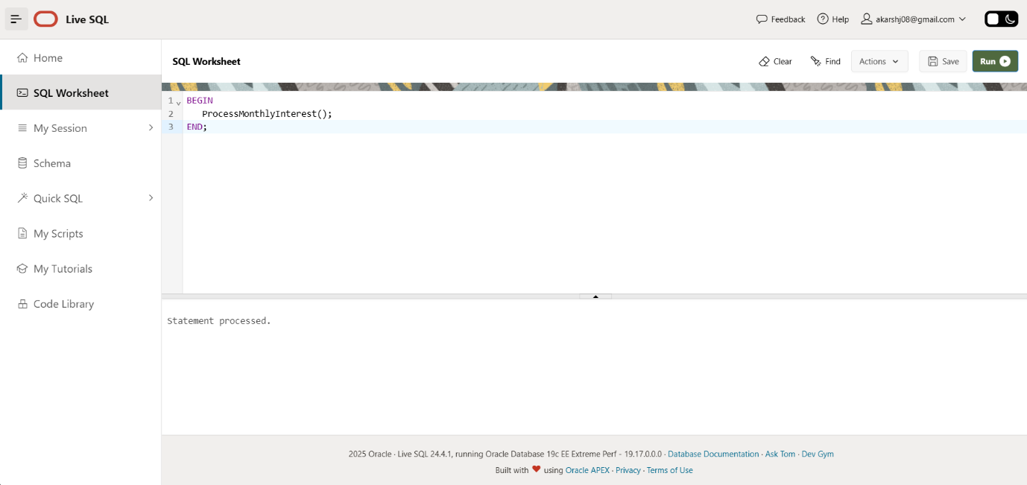

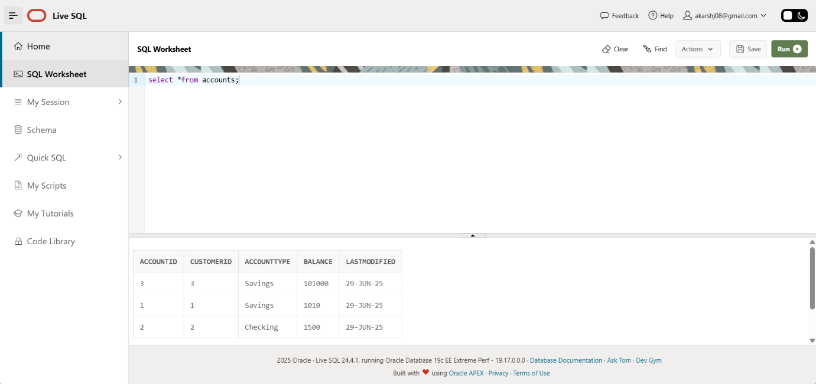

Scenario 2

Code ->

CREATE OR REPLACE PROCEDURE UpdateEmployeeBonus (

p_Department IN VARCHAR2,

p_BonusPercent IN NUMBER

) AS

BEGIN

UPDATE Employees

SET Salary = Salary + (Salary * p_BonusPercent / 100)

WHERE Department = p_Department;

COMMIT;

END;

BEGIN

UpdateEmployeeBonus('Developer', 10);

END;

Output ->

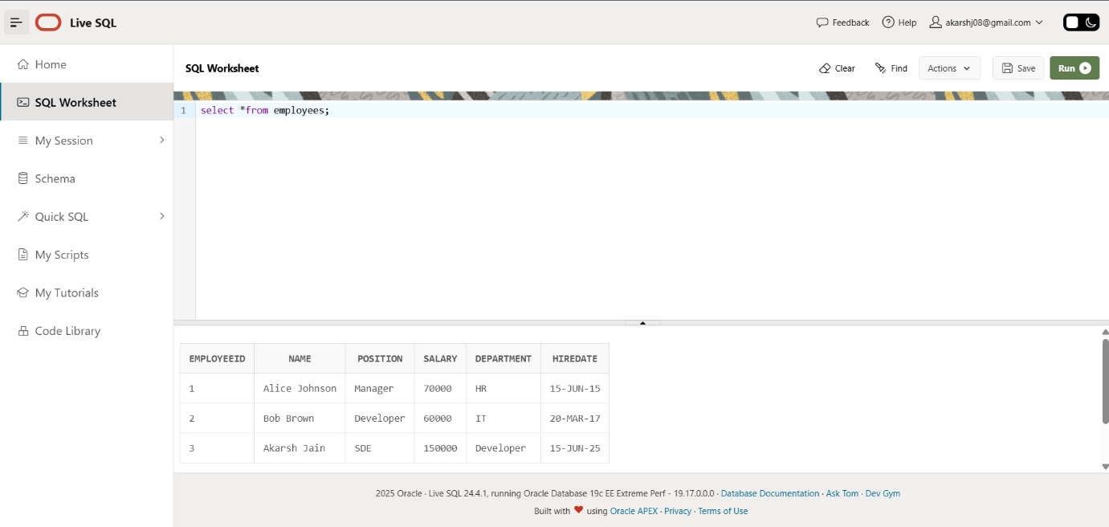

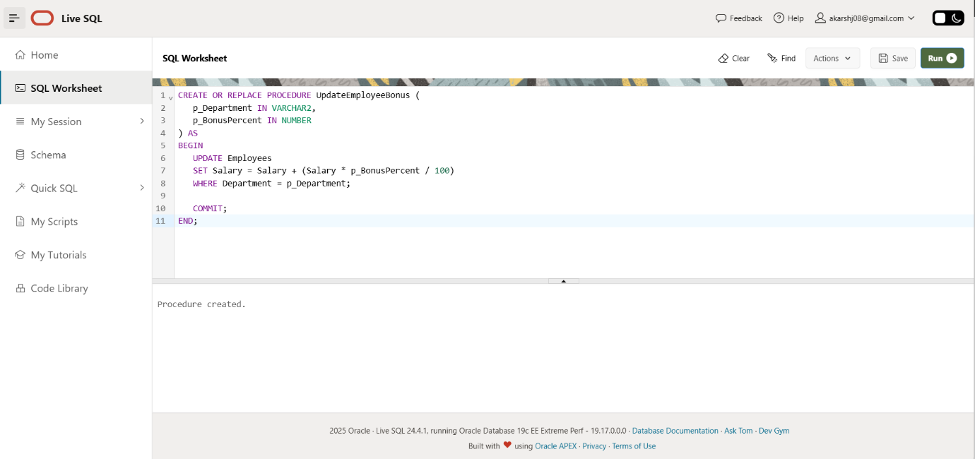

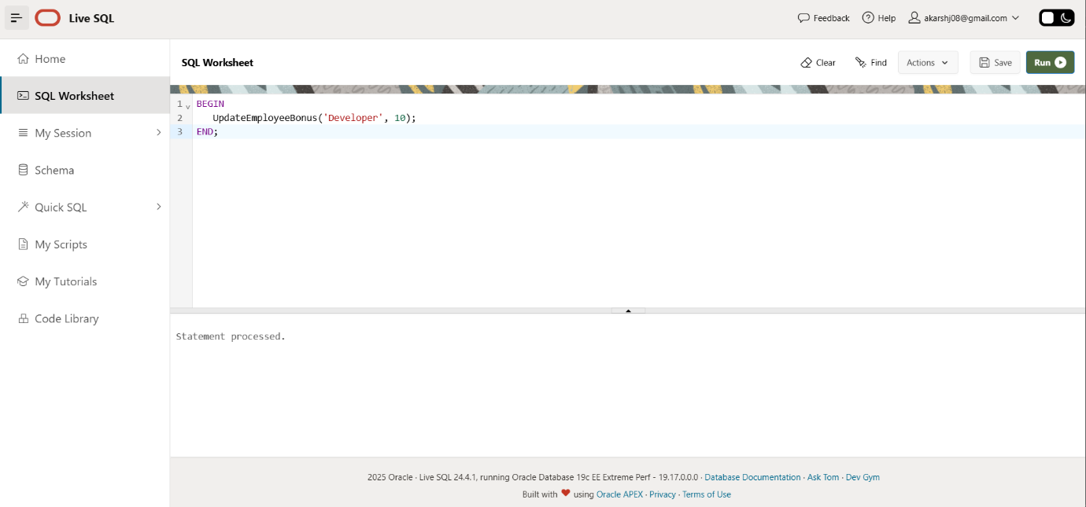

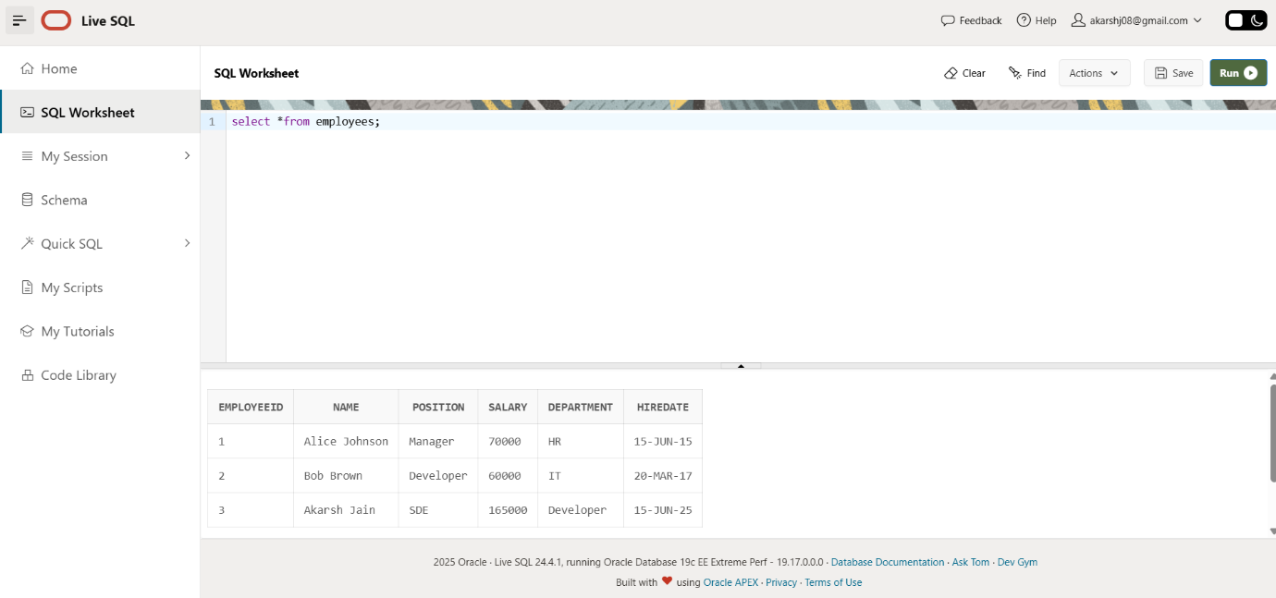

Scenario 3

Code ->

CREATE OR REPLACE PROCEDURE TransferFunds (

p_FromAccountID IN NUMBER,

p_ToAccountID IN NUMBER,

p_Amount IN NUMBER

) AS

v_FromBalance NUMBER;

BEGIN

SELECT Balance INTO v_FromBalance

FROM Accounts

WHERE AccountID = p_FromAccountID

FOR UPDATE;

IF v_FromBalance < p_Amount THEN

RAISE_APPLICATION_ERROR(-20001, 'Insufficient balance in source account.');

END IF;

UPDATE Accounts

SET Balance = Balance - p_Amount,

LastModified = SYSDATE

WHERE AccountID = p_FromAccountID;

UPDATE Accounts

SET Balance = Balance + p_Amount,

LastModified = SYSDATE

WHERE AccountID = p_ToAccountID;

COMMIT;

END;

BEGIN

TransferFunds(1, 2, 500);

END;

Output ->

